**QUERIES**

An SQL Update statement using WHERE

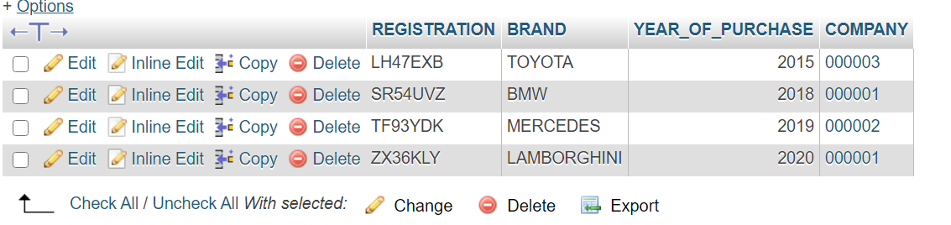INSERT INTO `EXAMINATION_CENTRE` (`LOCATION`) VALUES('123456');





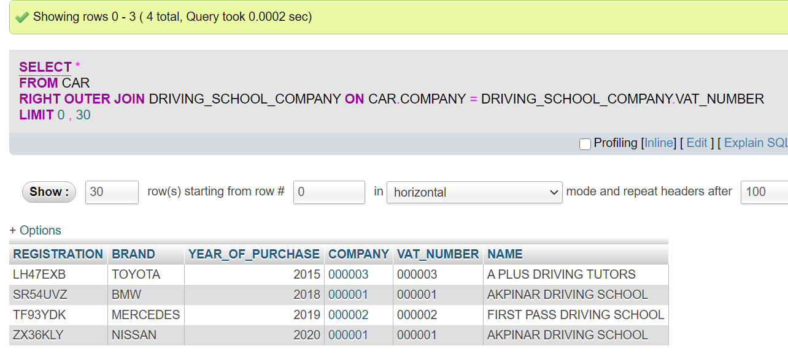An outer join SQL query

A correlated SQL query with NOT EXISTS

SELECT EMPLOYEE_ID, NAME

FROM EXAMINER EX

WHERE NOT EXISTS

(SELECT *

FROM DRIVING_LICENSE_EXAM_APPLICANT DLEA

WHERE NOT EXISTS

(SELECT *

FROM EXAM_OPPORTUNITY EO

WHERE EX.EMPLOYEE_ID = EO.ASSIGNEE

AND DLEA.SSN = EO.TRIED_BY));

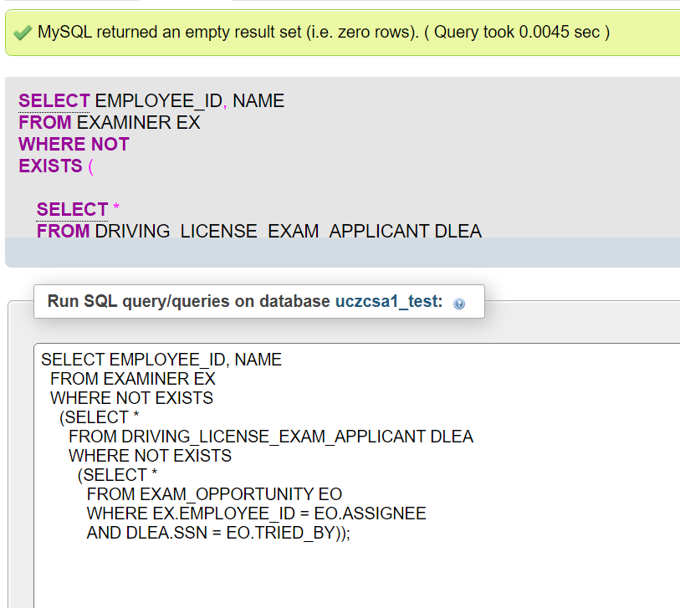

Selecting examiners who are not taking up any exam opportunities

SELECT EX.EMPLOYEE_ID

FROM EXAMINER EX

WHERE NOT EXISTS

(SELECT *

FROM EXAM_OPPORTUNITY EXO

WHERE EX.EMPLOYEE_ID = EXO.ASSIGNEE);

